# JavaScript testing

|  |  |  |  |  |
| --- | --- | --- | --- | --- |
| Test location | Unit test | Expected result | Returned result | Evaluation |
| Form submission | If the user enters blank in the date field | Should set the date value to today’s date in the form “dd/mm/yyyy” | Sets the date value to today’s date in the form “dd/mm/yyyy” | Correct |
|  | If the user enters today’s date in the date field | Should set the date value to the entered date in the form “dd/mm/yyyy” | Sets the date value to the entered date in the form “dd/mm/yyyy” | Correct |
|  | If the user enters future date in the date field | Should set the date value to the entered date in the form “dd/mm/yyyy” | Sets the date value to the entered date in the form “dd/mm/yyyy” | Correct |
|  | If the user enters past date in the date field | Should set the date value to the entered date in the form “dd/mm/yyyy” | Sets the date value to the entered date in the form “dd/mm/yyyy” | Correct |
|  | If the user inputs a blank string into the comment text box | Should set the comment value to “No comments needed” | Sets the comment value to “No comments needed” | Correct |
|  | If the user inputs a string into the comments text box | Should set the comment value to the inputted string | Sets the comment value to the string in the form | Correct |
| Visual warnings | If the user is R it should add the r related button | Should add a R button into the html | Adds the R button into the html | Correct |
|  | If the user is G it should add the r related button | Should add a G button into the html | Adds the G button into the html | Correct |
|  | If the user is Y it should add the r related button | Should add a Y button into the html | Adds the Y button into the html | Correct |
|  | If the user is “” it should not add a button | Should not add a button into the html | Doesn’t add a button into the html | Correct |
|  | If the user is 0 it should not add a button | Should not add a button into the html | Doesn’t add a button into the html | Correct |
|  | If the user is int max, it should not add a button | Should not add a button into the html | Doesn’t add a button into the html | Correct |
|  | If the user is minus int max, it should not add a button | Should not add a button into the html | Doesn’t add a button into the html | Correct |

# JavaScript testing with Mocha

## Code

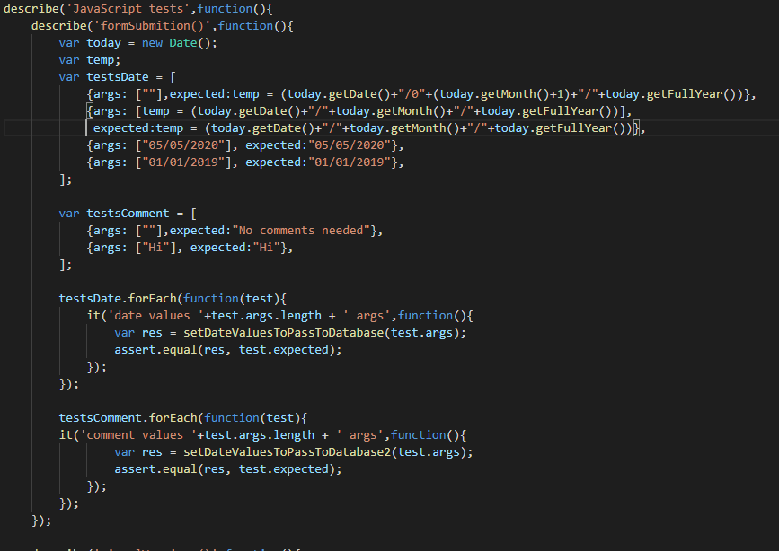

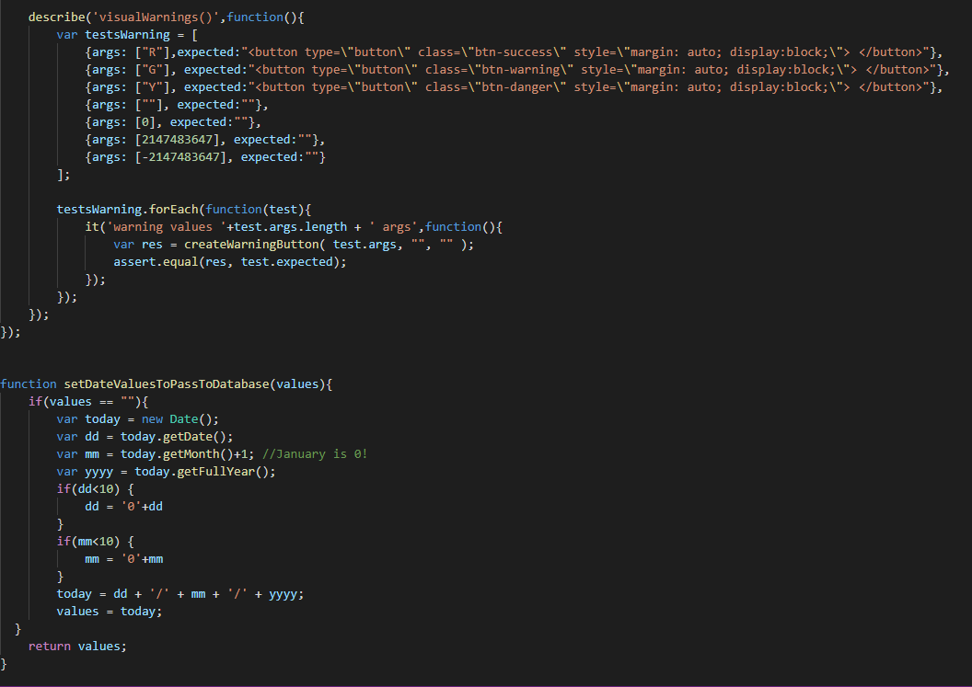

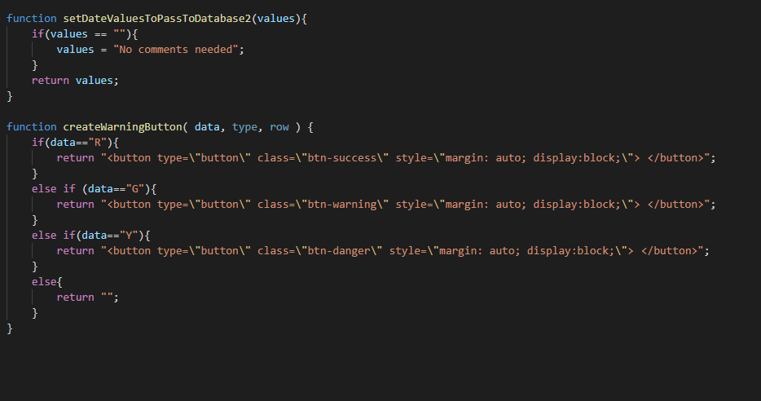

## Returned value

# Python testing

|  |  |  |  |  |
| --- | --- | --- | --- | --- |
| Test location | Unit test | Expected result | Returned result | Evaluation |
| Routing | Check to see if the database is empty | Should return no users from the database | No users were returned from the database | Correct |
|  | Check to see if a user has been added to the database | Should add a user to the database | A user was added to the database | Correct |
|  | Check to see if you can send a user’s manual input to the database | Should add the users manual input to the database | The users manual input was added to the database | Correct |
|  | Check to see if you can get a patient from the database | Should get a user from the database | A user was returned from the database | Correct |

# Python testing with pytest

## Code

